**le Brocquy, Louis (1916-2012)**

Born in Dublin, Louis le Brocquy became one of the most significant figures in Irish twentieth century art. After a major role in the organisation of the Irish Living Art Exhibition in 1943, he moved to London where he was active in the contemporary art scene. In 1958, le Brocquy moved to the South of France with his wife, the painter Ann Madden, remaining there until their return to Dublin in 2000. His painting *A Family* (1951) won the Prealpina Painting Prize at the Venice Biennale in 1958; after having been rejected by the Hugh Lane Gallery in Dublin in the 1950s, it finally entered the collection of the National Gallery of Ireland in 2000. *A Family* addresses Cold War anxieties through a reading of both Picasso and Manet; the *Presences* series(1954-1964) examined the female body through a visual language close to the French Inform (l’Informe). However, a significant theme in le Brocquy’s work from the 1960s onwards utilised the Celtic cult of the head as a basis for studies of modernist artists and writers including Francis Bacon, James Joyce and Federico García Lorca, thus firmly located Irish identity within the wider context of European modernism.

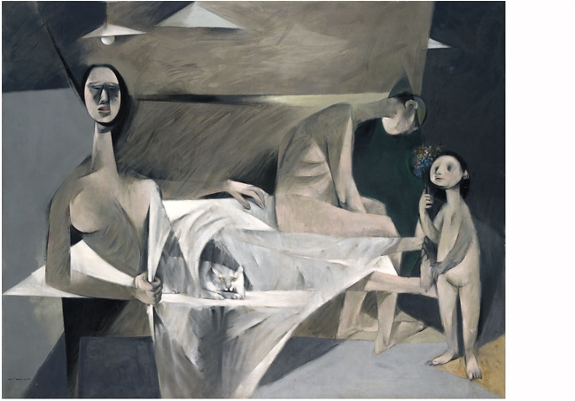

Louis le Brocquy *A Family* 1951 <http://www.nationalgallery.ie/en/Collection/Irelands_Favourite_Painting/Final_brocquy.aspx>

References and Further Reading

Coulter, R. (2008) ‘Louis le Brocquy’s *Presences*, 1954-64: Irish, British or International?’ *The Irish Review,* 39, Winter, pp.139-156

Kennedy, R. (2005) ‘Made in England: The Critical Reception of Louis le Brocquy’s “A Family” ‘, *Third Text* XIX/5, pp.475-486

Le Brocquy, L. (2006) *The Head Image: Notes on Painting and Awareness,* Dublin, Irish Museum of Modern Art

Madden le Brocquy, A. (1994) *A Painter: Seeing his Way,* Dublin: Gill and MacMillan

Smith, A. (1996) *Louis le Brocquy: Paintings 1939-1996* Dublin: Irish Museum of Modern Art